# Draft-Memo

|  |  |
| --- | --- |
| Date: | Thursday, October 02, 2014 |
| Project: | I-4 SAMR Re-evaluation |
| To: | Beata Styś Pałasz, PE, FDOT District Five |
| From | Hari Salkapuram, PE, HDR; ; Suraj Pamulapati, PE, HDR |
| Subject: | **Saxon Boulevard Interchange Alternatives Evaluation** |

1. **Purpose**

The Florida Department of Transportation (FDOT) has requested to evaluate interchange alternatives for the Saxon Boulevard interchange in the north section presented in the Interstate 4 (I‑4) Systems Access Modification Report (SAMR) Re-evaluation in support of “I-4 Beyond the Ultimate (BtU)” PD&E Reevaluation Study.

1. **Project Location**

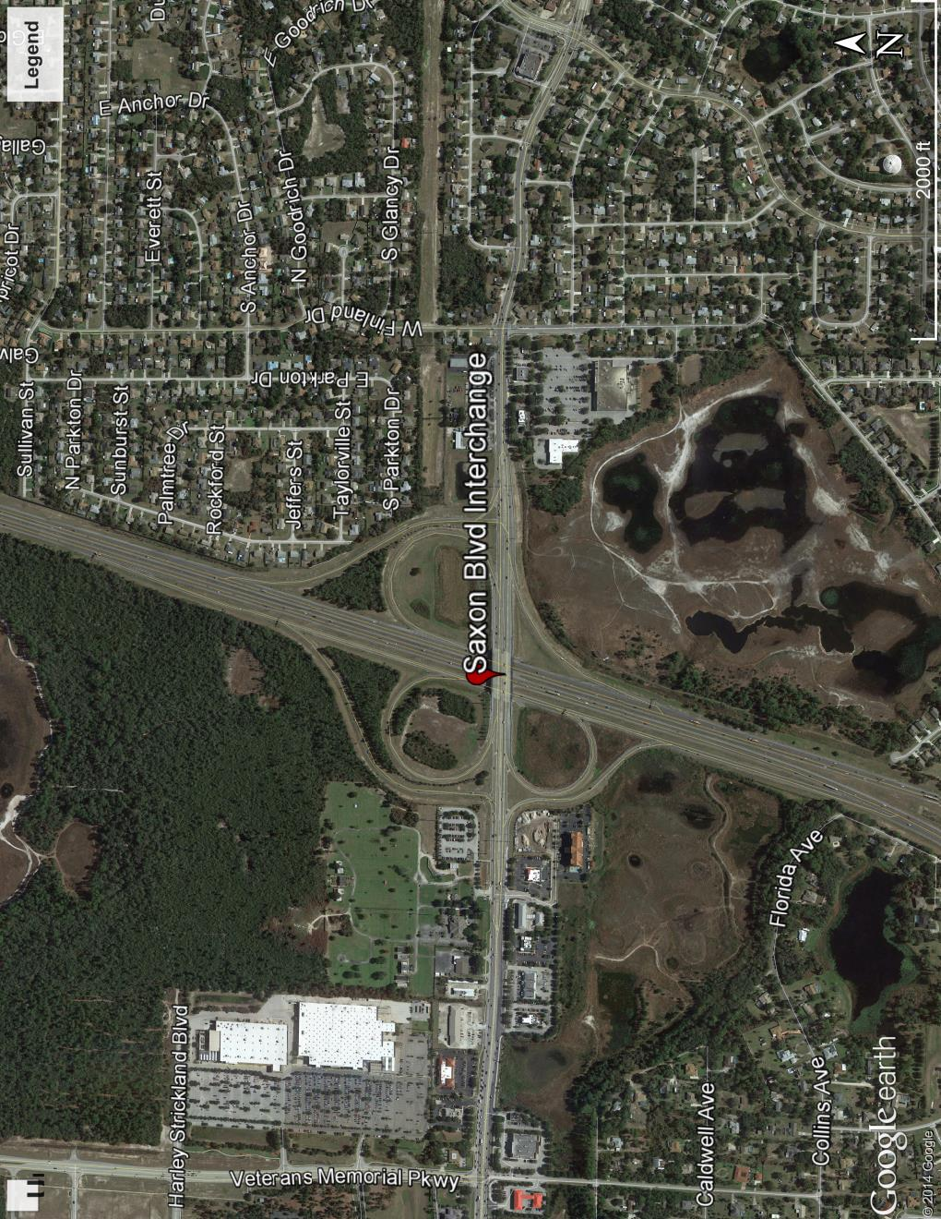

Figure : Saxon Blvd Interchange Location

1. **Analysis Year**

The analysis year for the alternative evaluation is the Design Year (2040).

1. **Traffic Forecasts**

This traffic analysis for the analysis year 2040 was performed based on traffic forecasts developed as part of the I-4 SAMR Re-evaluation that is being prepared to support the I-4 BtU PD&E Reevaluation Study. The traffic forecasts for the analysis year 2040 are included in **Attachment A**.

1. **Interchange Alternatives**

Two alternatives were considered for the Saxon Boulevard interchange evaluation. The list of alternatives is provided below and detailed geometry of the alternatives is provided in **Attachment B**.

1. No-Build
2. Alternative 1– This alternative consists of following intersection improvements in additiona to No-Build geometry.
   1. Continuous right turn lane in both eastbound and westbound directions between the east bound ramps terminal and Finland Drive intersection.
   2. Saxon Blvd widening to three lanes from eastbound ramps terminal to Normandy Blvd intersection.
   3. A second northbound left turn and an exclusive southbound left turn at Finland drive intersection.
   4. Dual northbound left turns, dual eastbound left turns and a southbound channelized free flow right turn at Normandy Blvd intersection
3. **Operational Analysis**

This section discusses peak-hour operational analysis using Synchro software. The results of the analysis and a comparison between the Alternatives are provided below.

* 1. **Intersection Evaluation**

A separate AM and PM peak-hour intersection analysis for study intersections was completed in Synchro for the study intersections on Saxon Blvd.

Network-wide output provides insight into the comparison between the Alternatives. Based on the network performance comparisons, Alternative 1 provides improved operational performance for the 2040 AM and PM peak-hour periods (**Table 1**).

Table : Saxon Boulevard Intersections - Measures of Effectiveness (MOEs) Comparison



Synchro Intersection Delay and LOS Summary is shown in **Table 2**.

Table 2: Saxon Boulevard Intersections – Average Delay and LOS Comparison



* 1. **Queue Analysis**

The queuing for both eastbound and westbound ramps was not conducted because the ramp movements are free flow.

1. **Conclusion**

Based on the operational analyses of No-Build alternative and Alternative 1, Alternative 1 performs better than No-Build Alternative.

1. **Recommendation**

Review of Alternative 1 in addition to No-Build was conducted for Saxon Blvd interchange for the analysis year 2040. Based on the operational analysis, Alternative 1 provides better operational performance than No-Build. Based on the assessments and analyses of the alternatives, Alternative 1 is recommended. However, other factors such as costs, ROW, environmental considerations, and funding availability should be considered in the implementation.