# Draft-Memo

|  |  |
| --- | --- |
| Date: | Tuesday, November 18, 2014 |
| Project: | I-4 SAMR Re-evaluation |
| To: | Beata Styś Pałasz, PE, FDOT District Five |
| From | Hari Salkapuram, PE, HDR; Smith Siromaskul, P.E., P. Eng, HDR |
| Subject: | **Dirksen Drive Interchange Alternatives Evaluation** |

1. **Purpose**

The Florida Department of Transportation (FDOT) has requested to evaluate interchange alternatives for the Dirksen Drive interchange in the north section presented in the Interstate 4 (I‑4) Systems Access Modification Report (SAMR) Re-evaluation in support of “I-4 Beyond the Ultimate (BtU)” PD&E Reevaluation Study.

1. **Project Location**

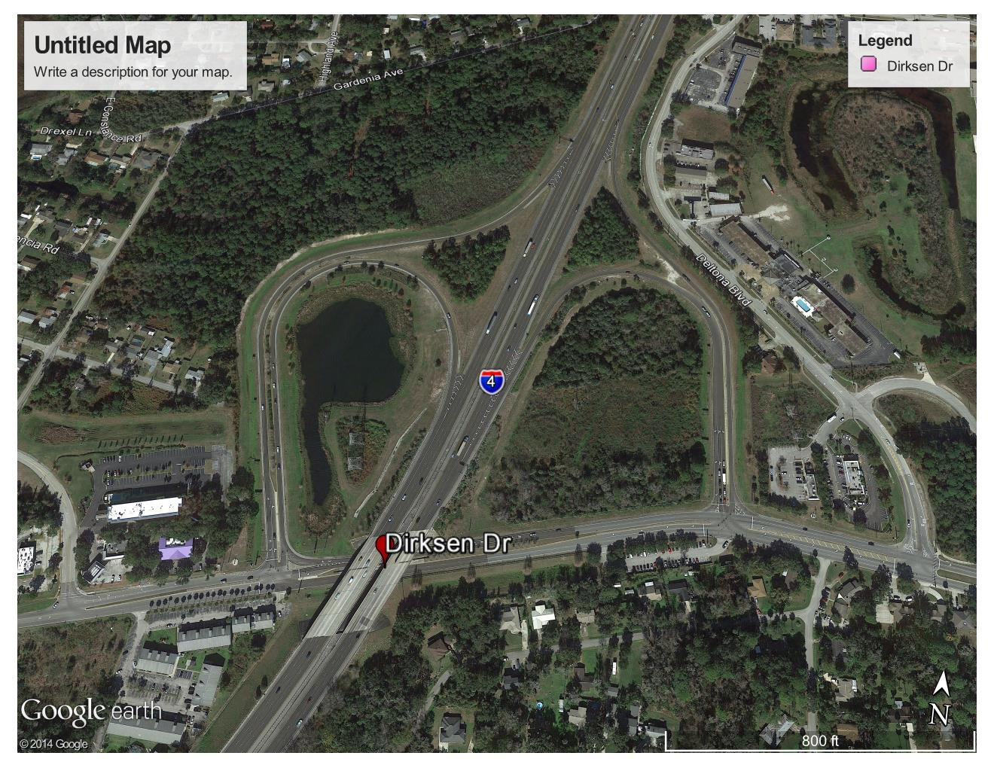

Figure 1: Dirksen Drive Interchange Location

1. **Analysis Year**

The analysis year for the alternative evaluation is the Design Year (2040).

1. **Traffic Forecasts**

This traffic analysis for the analysis year 2040 was performed based on traffic forecasts developed as part of the I-4 SAMR Re-evaluation that is being prepared to support the I-4 BtU PD&E Reevaluation Study. The traffic forecasts for the analysis year 2040 are included in **Attachment A**.

1. **Interchange Alternatives**

Two alternatives were considered for the Dirksen Drive interchange evaluation. The list of alternatives is provided below and detailed geometry of the alternatives is provided in **Attachment B**.

1. No-Build - Existing + Four lanes on Dirksen west of the interchange
2. Alternative 1 – Free Flow Ramp at I-4 eastbound ramp terminus. This alternative includes following additional improvements at the adjacent intersections.
   1. A free flow right lane onto the WB on-ramp (requires 2 receiving lanes before merging to 1 in order to maintain free flow movement with opposing EBL) with a 3rd continuous WB lane between the ramp terminals.
   2. Dual eastbound left turn at the Deltona Blvd intersection and a dual southbound right turn lanes on Deltona Blvd.
3. **Operational Analysis**

This section discusses peak-hour operational analysis using microsimulation software VISSIM version 5.4. The results of the analysis and a comparison between the Alternatives are provided below. It should be noted that the operational analysis is proof of concept and is not based on calibrated VISSIM models. All of the simulation output is based on the average data from five (5) simulation runs.

* 1. **Node Evaluation**

A separate AM and PM peak hour intersection analysis for study area intersections was completed in VISSIM for the study intersections on Dirksen Drive. Intersection Delay and LOS Summary is shown in **Table 1**. All intersections operate at an LOS C or better in the Alternative 1. It is worth noting that weaving is a concern with the free flow ramp, but is not something that can easily be quantified in the analysis.  Potential solutions to improve the weaving distance is to pull the free flow ramp as far back to the west as possible or possible relocation of Deltona Blvd intersection to the east at Welcome Center Dr.  Right now free flow ramp connects to Dirksen approximately 300 feet from the existing ramp terminal intersection.

Table 1 – I-4 and Dirksen Drive Interchange -– Average Delay and LOS Comparison



* 1. **Network-Wide Output**

Network-wide output provides insight into the comparison between the Alternatives. Based on the network performance comparisons, Alternative 1 provides improved operational performance for the 2040 AM and PM peak hour periods (see **Table 1**). When considering total delay within the network in addition to latent delay for vehicles that are unable to enter the network, Alternative 1 reduces total delay time in the AM and PM peak hours by 86% and 83%, respectively. In addition, Alternative 1 provides additional improvements in interchange throughput (arrived vehicles) and latent demand (vehicles not allowed to enter the network due to congestion).

Table 2: Network Performance Comparison



1. **Conclusion**

Based on the operational analyses of the two alternatives, Alternative 1 performs better than No-Build alternative.

1. **Recommendation**

Review of two alternatives was conducted for Dirksen Drive interchange for the analysis year 2040. Based on the operational analysis, Alternative 1 provides better operational performance among the three alternatives, ultimately improving mobility throughout the Dirksen Drive corridor. Based on the assessments and analyses of the alternatives, Alternative 1 is recommended. However, other factors such as costs, ROW, environmental considerations, and funding availability should be considered in the implementation.