# Draft-Memo

|  |  |
| --- | --- |
| Date: | Wednesday, October 15, 2014 |
| Project: | I-4 SAMR Re-evaluation |
| To: | Beata Styś Pałasz, PE, FDOT District Five |
| From | Hari Salkapuram, PE, HDR; Suraj Pamulapati, PE, HDR |
| Subject: | **Orange Camp Road Interchange Alternatives Evaluation** |

1. **Purpose**

The Florida Department of Transportation (FDOT) has requested to evaluate interchange alternatives for the Orange Camp Road interchange in the north section presented in the Interstate 4 (I‑4) Systems Access Modification Report (SAMR) Re-evaluation in support of “I-4 Beyond the Ultimate (BtU)” PD&E Reevaluation Study.

1. **Project Location**

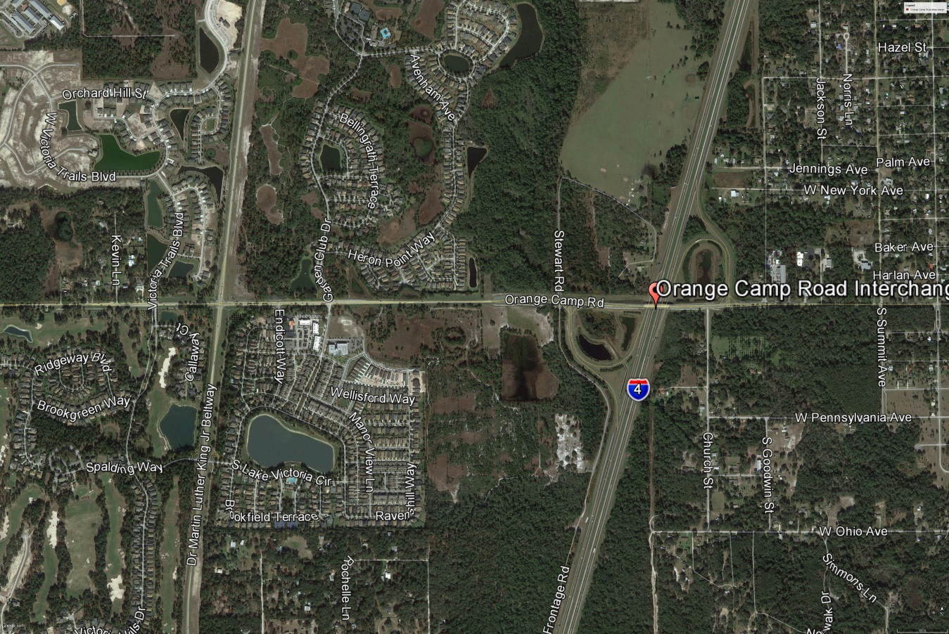

Figure : Orange Camp Road Interchange Location

1. **Analysis Year**

The analysis year for the alternative evaluation is the Design Year (2040).

1. **Traffic Forecasts**

This traffic analysis for the analysis year 2040 was performed based on traffic forecasts developed as part of the I-4 SAMR Re-evaluation that is being prepared to support the I-4 BtU PD&E Reevaluation Study. The traffic forecasts for the analysis year 2040 are included in **Attachment A**.

1. **Interchange Alternatives**

Two alternatives were considered for the Orange Camp Road interchange evaluation. The list of alternatives is provided below and detailed geometry of the alternatives is provided in **Attachment B**.

1. No-Build – Originally approved FHWA alternative
2. Alternative 1 – Signals at both Eastbound and Westbound I-4 Ramps Intersections
3. **Operational Analysis**

This section discusses peak-hour operational analysis using Synchro software. The results of the analysis and a comparison between the Alternatives are provided below.

* 1. **Intersection Evaluation**

A separate AM and PM peak-hour intersection analysis for study intersections was completed in Synchro for the study intersections on Orange Camp Road.

Network-wide output provides insight into the comparison between the Alternatives. Based on the network performance comparisons, Alternative 1 provides improved operational performance for the 2040 AM and PM peak-hour periods (**Table 1**).

Table : Orange Camp Road Intersections - Measures of Effectiveness (MOEs) Comparison



* 1. **Queue Analysis**

The queuing results for the intersections of Orange Camp Road with I-4 Ramps are summarized in **Table 2** for the analysis year 2040. The results indicate that Alternative 1 results in better queue performance for both eastbound and westbound ramps for both the AM and PM peak hour conditions.

Table : Queue Analysis Summary



1. **Conclusion**

Based on the operational analyses of the alternatives, Alternative 1 performs better than the No-Build Alternative.

1. **Recommendation**

Review of only one alternative in addition to No-Build was conducted for Orange Camp Road interchange for the analysis year 2040. Based on the operational analysis, Alternative 1 provides better operational performance than No-Build Alternative. Based on the assessments and analyses of the alternatives, Alternative 1 is recommended.