# Draft-Memo

|  |  |
| --- | --- |
| Date: | Thursday, October 02, 2014 |
| Project: | I-4 SAMR Re-evaluation |
| To: | Beata Styś Pałasz, PE, FDOT District Five |
| From | Hari Salkapuram, PE, HDR; Suraj Pamulapati, PE, HDR |
| Subject: | **SR 46 Interchange Alternatives Evaluation** |

1. **Purpose**

The Florida Department of Transportation (FDOT) has requested to evaluate interchange alternatives for the SR 46 interchange in the north section presented in the Interstate 4 (I‑4) Systems Access Modification Report (SAMR) Re-evaluation in support of “I-4 Beyond the Ultimate (BtU)” PD&E Reevaluation Study.

1. **Project Location**

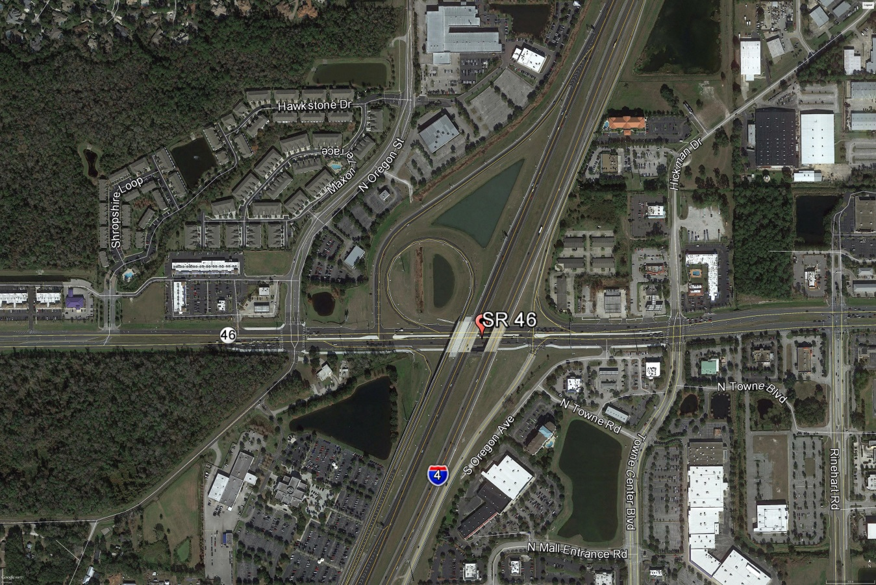

Figure : SR 46 Interchange Location

1. **Analysis Year**

The analysis year for the alternative evaluation is the Design Year (2040).

1. **Traffic Forecasts**

This traffic analysis for the analysis year 2040 was performed based on traffic forecasts developed as part of the I-4 SAMR Re-evaluation that is being prepared to support the I-4 BtU PD&E Reevaluation Study. The traffic forecasts for the analysis year 2040 are included in **Attachment A**.

1. **Interchange Alternatives**

Three alternatives were considered for the SR 46 interchange evaluation. The list of alternatives is provided below and detailed geometry of the alternatives is provided in **Attachment B**.

1. No-Build – Originally approved FHWA alternative
2. Alternative 1 – No-Build + second eastbound left turn lane at eastbound ramps intersection
3. Alternative 2 – Alt 1 + Slip Ramp from I-4 eastbound off ramp at SR 46 to N Towne Road/Towne Center Boulevard
4. **Operational Analysis**

This section discusses peak-hour operational analysis using Synchro software. The results of the analysis and a comparison between the Alternatives are provided below.

* 1. **Intersection Evaluation**

A separate AM and PM peak-hour intersection analysis for study intersections was completed in Synchro for the study intersections on SR 46.

Network-wide output provides insight into the comparison between the Alternatives. Based on the network performance comparisons, Alternatives 1 and 2 provide improved operational performance for the 2040 AM and PM peak-hour periods while Alternative 2 provides marginally better performance than Alternative 1 (**Table 1**).

Table 1: Lake Mary Boulevard Intersections - Measures of Effectiveness (MOEs) Comparison



Synchro Intersection Delay and LOS Summary is shown in **Table 2**.

Table 2: Lake Mary Boulevard Intersections – Average Delay and LOS Comparison



* 1. **Queue Analysis**

The queuing results for the intersections of SR 46 with I-4 Ramps are summarized in **Table 3** for the analysis year 2040. The results indicate that Alternative 2 results in better queue performance for both eastbound and westbound ramps.

Table 3: Queue Analysis Summary



1. **Conclusion**

Based on the operational analyses of all the alternatives, Alternative 2 performs better than the other alternatives.

1. **Recommendation**

Review of two alternatives in addition to No-Build was conducted for SR 46 interchange for the analysis year 2040. Based on the operational analysis, Alternative 2 provides better operational performance among the alternatives. Based on the assessments and analyses of the alternatives, Alternative 2 is recommended. However, other factors such as costs, ROW, environmental considerations, and funding availability should be considered in the implementation.