# Draft-Memo

|  |  |
| --- | --- |
| Date: | Tuesday, November 18, 2014 |
| Project: | I-4 SAMR Re-evaluation |
| To: | Beata Styś Pałasz, PE, FDOT District Five |
| From | Hari Salkapuram, PE HDR; Smith Siromaskul, P.E., P. Eng. HDR |
| Subject: | **CR 46A Interchange Alternatives Evaluation** |

1. **Purpose**

The Florida Department of Transportation (FDOT) has requested to evaluate interchange alternatives for the CR 46A interchange in the north section presented in the Interstate 4 (I‑4) Systems Access Modification Report (SAMR) Re-evaluation in support of “I-4 Beyond the Ultimate (BtU)” PD&E Reevaluation Study.

1. **Project Location**

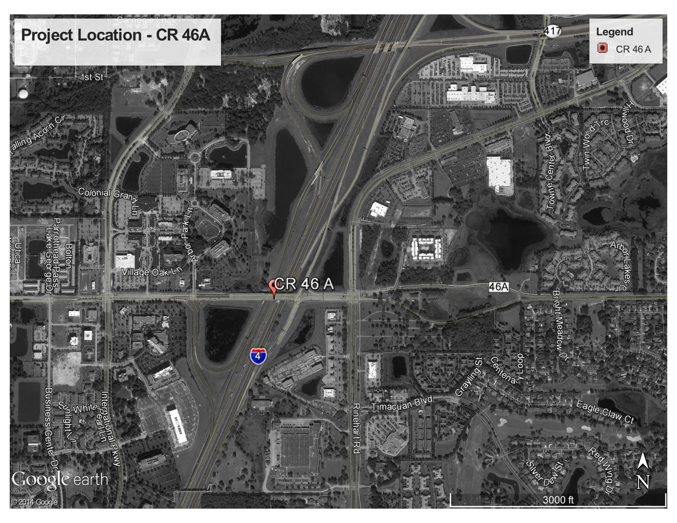

Figure 1: CR 46A Interchange Location

1. **Analysis Year**

The analysis year for the alternative evaluation is the Design Year (2040).

1. **Traffic Forecasts**

This traffic analysis for the analysis year 2040 was performed based on traffic forecasts developed as part of the I-4 SAMR Re-evaluation that is being prepared to support the I-4 BtU PD&E Reevaluation Study. The traffic forecasts for the analysis year 2040 are included in **Attachment A**.

1. **Interchange Alternatives**

Three alternatives were considered for the CR 46A interchange evaluation. The list of alternatives is provided below and detailed geometry of the alternatives is provided in **Attachment B**.

1. No-Build – Originally approved FHWA alternative.
2. Alternative 1 – CR 46A widening to six lanes.
3. Alternative 2 - CR 46A, contraflow lanes and restricted movements at Rinehart Road
4. **Operational Analysis**

This section discusses peak-hour operational analysis using microsimulation software VISSIM version 5.4. The results of the analysis and a comparison between the Alternatives are provided below. It should be noted that the operational analysis is proof of concept and is not based on calibrated VISSIM models. All of the simulation output is based on the average data from five (5) simulation runs.

* 1. **Node Evaluation**

A separate AM and PM peak hour intersection analysis for study area intersections was not conducted due to the complex nature of the intersections in Alternative 2. Given the unique geometry of the interchange improvements in Alternative 2, a direct comparison of intersection operations was not possible.

* 1. **Network-Wide Output**

Network-wide output provides insight into the comparison between the Alternatives. Based on the network performance comparisons, Alternative 2 provides improved operational performance for the 2040 AM and PM peak hour periods (see **Table 1**). When considering total delay within the network in addition to latent delay for vehicles that are unable to enter the network, Alternative 2 reduced total delay time in the AM and PM peak hours by 53% and 67%, respectively. In addition, Alternative 2 provides additional improvements in interchange throughput (arrived vehicles) and latent demand (vehicles not allowed to enter the network due to congestion).

Table 1: Network Performance Comparison



* 1. **Queue Analysis**

A queuing analysis was performed at all ramp terminal intersections in order to determine maximum queue lengths (in feet) that would impact I-4. The queuing results for the intersections of CR 46A and the I-4 ramps are summarized in **Table 2** for the analysis year 2040. The results indicate that Alternative 2 significantly reduces the queue lengths for both eastbound and westbound ramps for both the AM and PM conditions.

Table 2: Queue Analysis Summary



1. **Conclusion**

Based on the operational analyses of the alternatives, Alternative 2 performs better than the No-Build and Alternative 1.

1. **Recommendation**

Review of three alternatives for CR 46A interchange was conducted for the analysis year 2040. Based on the operational analysis, it is clear that Alternative 2 provides better operational performance among the three alternatives, ultimately improving mobility throughout the CR 46A corridor. Based on the assessments and analyses of the alternatives, Alternative 2 is recommended based on traffic performance metrics. However, other factors such as costs, environmental considerations, and funding availability should be considered in the implementation.