# Draft - Memo

|  |  |
| --- | --- |
| Date: | Tuesday, November 18, 2014 |
| Project: | I-4 SAMR Re-evaluation |
| To: | Beata Styś Pałasz, PE, FDOT District Five |
| From | Hari Salkapuram, PE, HDR; Suraj Pamulapati, PE, HDR |
| Subject: | **Lake Mary Blvd Interchange Alternatives Evaluation** |

1. **Purpose**

The Florida Department of Transportation (FDOT) has requested to evaluate interchange alternatives for the Lake Mary Blvd interchange in the north section presented in the Interstate 4 (I‑4) Systems Access Modification Report (SAMR) Re-evaluation in support of “I-4 Beyond the Ultimate (BtU)” PD&E Reevaluation Study.

1. **Project Location**

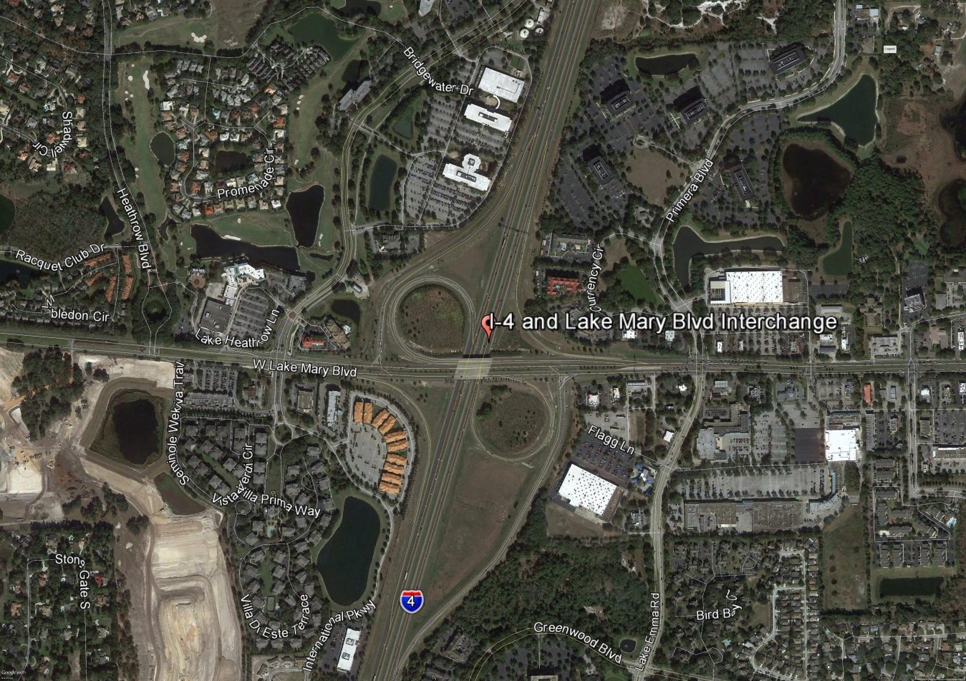

Figure : Lake Mary Boulevard Interchange Location

1. **Analysis Year**

The analysis year for the alternative evaluation is the Design Year (2040).

1. **Traffic Forecasts**

This traffic analysis for the analysis year 2040 was performed based on traffic forecasts developed as part of the I-4 SAMR Re-evaluation that is being prepared to support the I-4 BtU PD&E Reevaluation Study. The traffic forecasts for the analysis year 2040 are included in **Attachment A**.

1. **Interchange Alternatives**

Three alternatives were considered for the Lake Mary Boulevard interchange evaluation. The list of alternatives is provided below and detailed geometry of the alternatives is provided in **Attachment B**.

1. No-Build – Originally approved FHWA alternative
2. Alternative 1 – Single Point Urban Interchange (SPUI)
3. Alternative 2 – No-Build + Pedestrian Overpass across I-4+ Addt’l free NBR lane at I-4 WB Ramps intersection and exclusive 2nd EBR lane at Lake Emma Road intersection
4. **Operational Analysis**

This section discusses peak-hour operational analysis using Synchro software. The results of the analysis and a comparison between the Alternatives are provided below.

* 1. **Intersection Evaluation**

A separate AM and PM peak-hour intersection analysis for study intersections was completed in Synchro for the study intersections on Lake Mary Boulevard.

Network-wide output provides insight into the comparison between the Alternatives. Based on the network performance comparisons, Alternative 2 provides improved operational performance for the 2040 AM and PM peak-hour periods (**Table 1**).

Table : Lake Mary Boulevard Intersections - Measures of Effectiveness (MOEs) Comparison



Synchro Intersection Delay and LOS Summary is shown in **Table 2**.

Table 2: Lake Mary Boulevard Intersections – Average Delay and LOS Comparison



* 1. **Queue Analysis**

The queuing results for the intersections of Lake Mary Boulevard with I-4 Ramps are summarized in **Table 3** for the analysis year 2040. The results indicate that Alternative 2 results in better queue performance for both eastbound and westbound ramps.

Table 3: Queue Analysis Summary



1. **Conclusion**

Based on the operational analyses of all the alternatives, Alternative 2 performs better than the other alternatives.

1. **Recommendation**

Review of two alternatives in addition to No-Build was conducted for Lake Mary Boulevard interchange for the analysis year 2040. Based on the operational analysis, Alternative 2 provides better operational performance among the three alternatives, ultimately improving mobility throughout the Lake Mary Boulevard corridor. Based on the assessments and analyses of the alternatives, Alternative 2 is recommended. However, other factors such as costs, ROW, environmental considerations, and funding availability should be considered in the implementation.